

**ASSIGNMENT #2**

**NAME:** Saira Bano

**REG.NO:** FA22-BCS-107

**COURSE:** DSA

**SUBMITTED TO**: Mam Tahreem

**(a)**

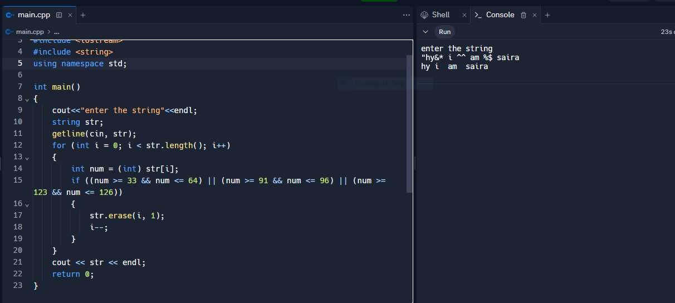

**(b)**

#include <iostream>

#include <string>

using namespace std;

string renameAdjacent(string str) {

for (int i = 1; i < str.length(); i++) {

if (str[i] == str[i-1]) {

if (str[i-1] == 'a') {

str[i] = 'b';

} else {

str[i] = 'a';

}

}

}

return str;

}

int main()

{

cout << "Enter the string: ";

string str;

getline(cin, str);

str = renameAdjacent(str);

cout << "String after renaming: " << str << endl;

return 0;

}

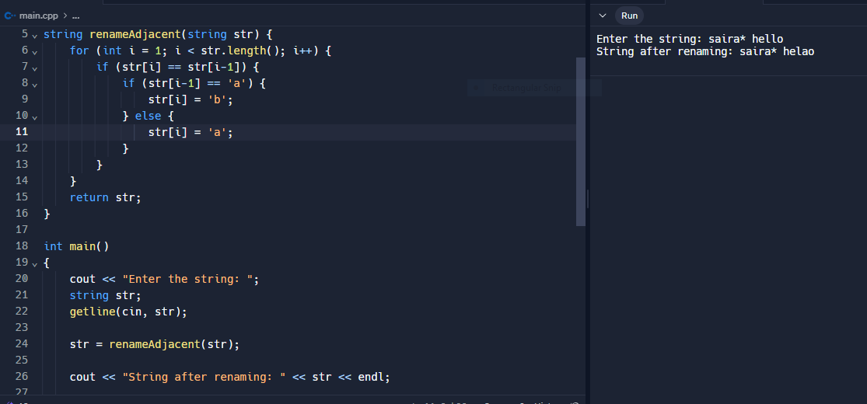

**(c)**

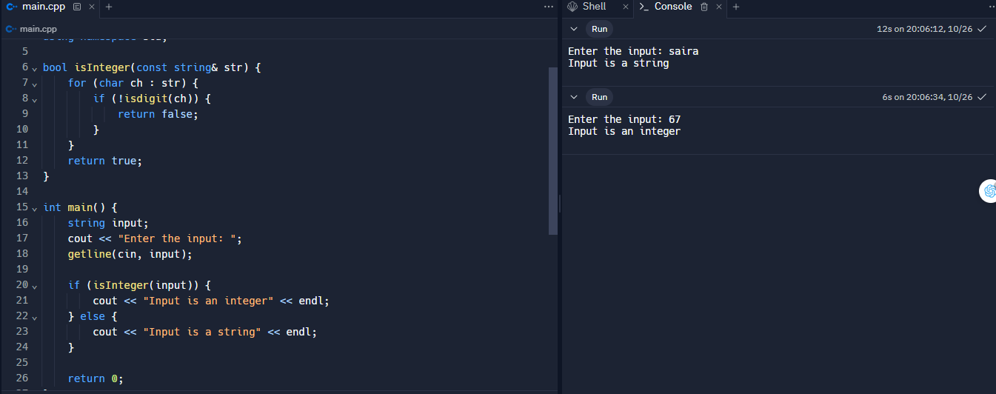

**(d)**

#include <iostream>

#include <unordered_map>

using namespace std;

char findMostFrequentChar(string str) {

unordered_map<char, int> charCount;

char mostFrequentChar;

int maxCount = 0;

for (char c : str) {

charCount[c]++;

if (charCount[c] > maxCount) {

maxCount = charCount[c];

mostFrequentChar = c;

}

}

return mostFrequentChar;

}

int main() {

string str = "Hello, World!";

char mostFrequentChar = findMostFrequentChar(str);

cout << "The most frequent character is: " << mostFrequentChar << endl;

return 0;

}

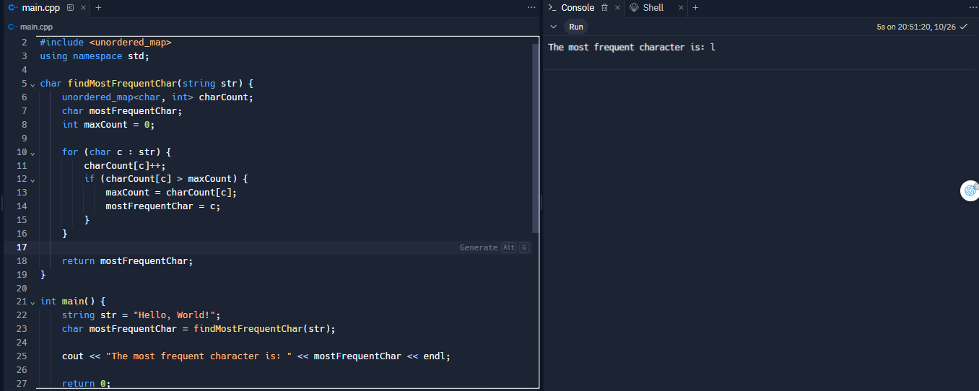

**(f)**

#include <iostream>

#include <string>

using namespace std;

string concatenateString(string str, int times) {

string result = "";

for (int i = 0; i < times; i++) {

result += str;

}

return result;

}

int main() {

string input = "Hello";

int times = 3;

string concatenatedString = concatenateString(input, times);

cout << "Concatenated String: " << concatenatedString << endl;

return 0;

}

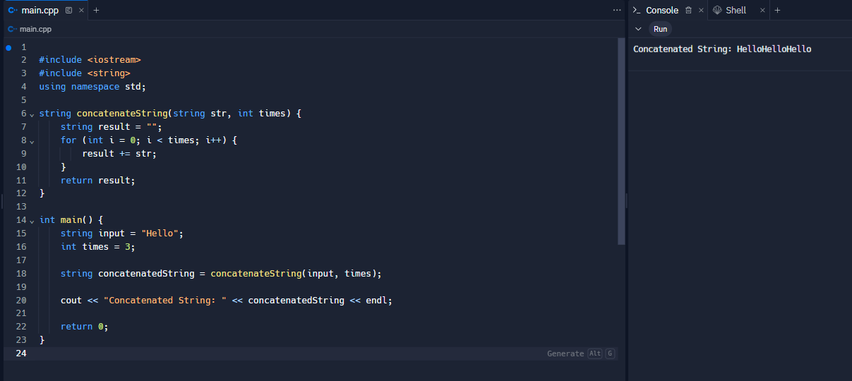

**(h)**

#include <iostream>

#include <string>

using namespace std;

int main() {

string str1, str2;

cout << "Enter string 1: ";

cin >> str1;

cout << "Enter string 2: ";

cin >> str2;

if (str1 == str2) {

cout << "Both strings are equal." << endl;

} else {

cout << "Strings are not equal." << endl;

}

return 0;

}

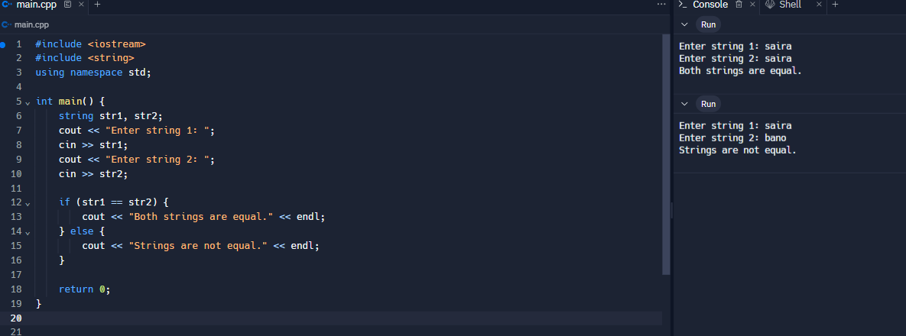

**(i)**

#include <iostream>

using namespace std;

int main()

{

cout<<"enter a string"<<endl;

string str;

cin>>str;

string num_str=" ";

for(int start=0; start<str.length(); start++) // Fixed error: added parentheses after str.length

{

if(str[start]>='0' && str[start]<='9') // Fixed error: changed >= to >='0' and <=9 to <='9'

{

num_str+= str[start];

}

}

cout<<"the extract integers are"<<num_str<<endl;

return 0;

}

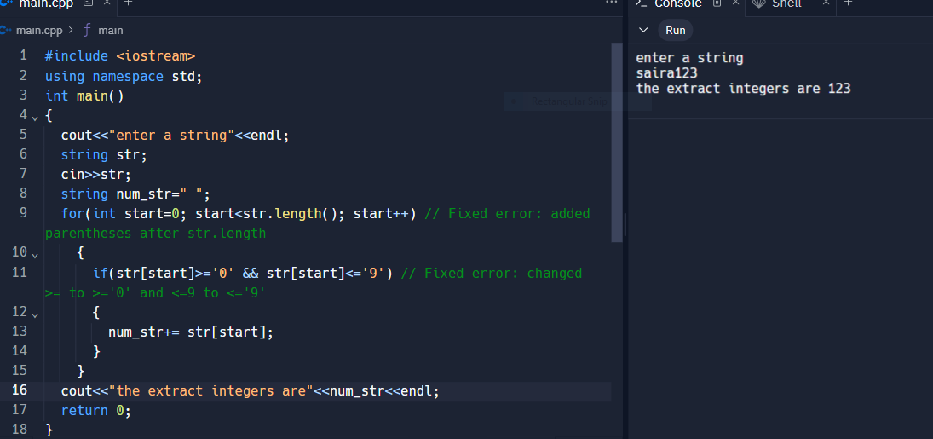

**(j)**

#include <iostream>

#include <string>

using namespace std;

int main() {

string text = "efficient.";

string oldWord = "sample";

string newWord = "replacement";

size_t pos = text.find(oldWord);

while (pos != string::npos) {

text.replace(pos, oldWord.length(), newWord);

pos = text.find(oldWord, pos + newWord.length());

}

cout << "good " << text << endl;

return 0;

}